CR-05 - Goals and Outcomes
Progress the jurisdiction has made in carrying out its strategic plan and its action plan. 91.520(a)
This could be an overview that includes major initiatives and highlights that were proposed and executed throughout the program year.

The City of Massillon, Ohio is an entitlement community under the U.S. Department of Housing and Urban Development (HUD) Community Development Block Grant program (CDBG). The City of Massillon has also joined with the City of Alliance and Stark County to form the Stark County HOME Consortium. As a member of the Consortium, the City has worked closely with these other local governments in the preparation of a Consolidated Plan for the City of Massillon. This plan provides a comprehensive overview of the area, identifying housing, homeless, and community development needs. As an entitlement community, the City of Massillon is also responsible for preparing, submitting, and administering its CDBG entitlement funds which it receives directly from HUD.
The City of Massillon continues to utilize CDBG funds to assist HUD with its mission to create strong, sustainable communities and quality affordable housing, while ensuring that all projects/activities funded must comply with one of the three national objectives – Benefit low/moderate income persons; Assist in the prevention or elimination of slums or blight; or Meet an urgent need.
The City of Massillon has worked diligently and is confident that Program Year 2025 projects/activities have met or exceeded the goals and objectives of the City’s Consolidated Plan and Annual Action Plan.
This Consolidated Annual Performance and Evaluation Report (CAPER) provided by the City of Massillon is intended to give necessary information to the citizens of Massillon, as well as the U. S. Department of Housing and Urban Development (HUD) and local area leaders, to meet the requirements and compliance with all applicable rules and regulations. This CAPER also provides information and public awareness regarding the accomplishments in meeting the goals and objectives of the Community’s CDBG program for the betterment of persons in need in the Massillon City limits. The City of Massillon’s 2025 CDBG Activities, their purpose, and their accomplishments are detailed below. The City of Massillon’s Housing Rehabilitation Program is detailed and included in Stark County’s 2025 CAPER.
Comparison of the proposed versus actual outcomes for each outcome measure submitted with the consolidated plan and explain, if applicable, why progress was not made toward meeting goals and objectives. 91.520(g)
Categories, priority levels, funding sources and amounts, outcomes/objectives, goal outcome indicators, units of measure, targets, actual outcomes/outputs, and percentage completed for each of the grantee’s program year goals.

Goal | Category | Source / Amount | Indicator | Unit of Measure | Expected – Strategic Plan | Actual – Strategic Plan | Percent Complete | Expected – Program Year | Actual – Program Year | Percent Complete
Affordable Housing Opportunity | Affordable Housing  Non-Homeless Special Needs | CDBG: $ | Homeowner Housing Rehabilitated | Household Housing Unit | 100 | 54 | 54.00% | 26 | 17 | 65.38%
Economic Development | Non-Housing Community Development | CDBG: $ | Facade treatment/business building rehabilitation | Business | 30 | 13 | 43.33% | 9 | 3 | 33.33%
Homeless Needs | Homeless | CDBG: $ | Homeless Person Overnight Shelter | Persons Assisted | 1500 | 2979 | 198.60% | 300 | 715 | 238.33%
Neighborhood Improvements | Non-Housing Community Development | CDBG: $ | Public Facility or Infrastructure Activities other than Low/Moderate Income Housing Benefit | Persons Assisted | 1625 | 0 | 0.00%
Neighborhood Improvements | Non-Housing Community Development | CDBG: $ | Buildings Demolished | Buildings | 50 | 0 | 0.00% | 5 | 0 | 0.00%
Non-Homeless Special Needs | Non-Homeless Special Needs | CDBG: $ | Public service activities other than Low/Moderate Income Housing Benefit | Persons Assisted | 1500 | 709 | 47.27% | 200 | 261 | 130.50%
Planning and Administration | Planning and Administration | CDBG: $ | Other | Other | 5 | 6 | 120.00%
Public Services | Non-Housing Community Development | CDBG: $ | Public service activities other than Low/Moderate Income Housing Benefit | Persons Assisted | 2200 | 2873 | 130.59% | 400 | 826 | 206.50%
Table 1 - Accomplishments – Program Year & Strategic Plan to Date

Assess how the jurisdiction’s use of funds, particularly CDBG, addresses the priorities and specific objectives identified in the plan, giving special attention to the highest priority activities identified.
AFFORDABLE HOUSING: The City of Massillon utilized CDBG entitlement funds for the costs of administration, staffing, & planning of the City's Housing Rehabilitation programs, including the correction of code enforcement violations cited by City code enforcement staff. These programs include CDBG funds & the City's part of the Stark County HOME consortium funds. The City awarded CDBG funds to Habitat for Humanity East Central Ohio for acquisition and rehabilitation of housing units for low income families. In addition to the 17 projects indicated, the Housing Department has several projects in progress.
ECONOMIC DEVELOPMENT:
- Massillon Main Street used funds for facade repairs/improvements to commercial buildings in the downtown business district.
HOMELESS NEEDS AND PUBLIC SERVICES:
- CommQuest's Family Living Center Homeless Shelter used funds to assist in the operation of the shelter providing temporary shelter to homeless persons/families. This program also provided other basic immediate needs and works to break the cycle of homelessness.
- Domestic Violence Shelter provided emergency protective housing to victims of domestic violence. Shelter residents had access to supportive services including counseling, therapy, alcohol & drug treatment programming, case management & legal advocacy services.
- Stark MHAR The Homeless Hotline serves as the Stark County Continuum of Care, centralized point of entry for persons seeking assistance with housing and social service needs.
NEIGHBORHOOD IMPROVEMENTS:
- The City's CDBG Demolition Program demolishes deteriorated and abandoned buildings, as well as buildings that must be demolished due to emergency situations such as fire damage, and that will alleviate blighting influences on neighborhoods.
PUBLIC SERVICES AND NON-HOUSING:
- Legacy Project Legacy Project of Stark County operates the imPACT and REMIX youth mentoring programs.
- Faith in Action provided transportation services to the LMI Elderly to remain in their homes & assist them with Medical appointments and personal errands.
- Habitat for Humanity ReStored provided funding for Hope ReStored vouchers, where residents transitioning from shelter to permanent housing can purchase new and gently used household goods.
- Salvation Army The coordinator of housing services provides better flow for those in need of housing that need to access services that our immediate community may not supply. Providing Stark County with the only 24 hour on call housing specialist, who is able to place the homeless in area motels until space is available in local shelters. Working with community leaders to transform the Massillon Community. The services helped those facing foreclosure or eviction, as well as provided education to alleviate these issues
- Stark Fresh Organization closed shortly after PY began and did not sign funding agreement.
- YMCA of Massillon received CDBG funding to provide scholarship memberships to low-to-moderate income families living in the City of Massillon.
2025 City Demolition Program
As indicated the City did not complete any demolitions this program year. However, there are five (5) demolition projects scheduled for demolition this fall. These projects will utilize 2024 and 2025 CDBG funds allocated for demolitions.

CR-10 - Racial and Ethnic composition of families assisted
Describe the families assisted (including the racial and ethnic status of families assisted). 91.520(a)

 | CDBG
White | 1,066
Black or African American | 569
Asian | 0
American Indian or American Native | 11
Native Hawaiian or Other Pacific Islander | 0

Total | 1,646

Hispanic | 30
Not Hispanic | 1,616

Table 2 – Table of assistance to racial and ethnic populations by source of funds

Narrative
The City of Massillon strives and is successful in reaching out and connecting with all persons of our city. The Community Development Department collects and maintains data to the extent of all racial and ethnic status. The City collects the data from all CDBG and HOME participants. The data is reported in the CR-10 chart above; persons assisted for CDBG. Stark County reports the data for HOME persons assisted.
The above table excludes individuals that identified as a race not listed above. City of Massillon’s CDBG program also assisted a large number of persons who were; Black or African American and White 118, and 26 people of other races not listed. That is a total of 2,047 people that received assistance.

CR-15 - Resources and Investments 91.520(a)
Identify the resources made available
Source of Funds | Source | Resources Made Available | Amount Expended During Program Year
CDBG | public - federal | 746,801 | 409,681
Table 3 - Resources Made Available

Narrative
In carrying out its housing and community development strategy, the City of Massillon utilizes CDBG entitlement funds which it received directly from HUD, and HOME funding which it receives through its participation in the Stark County Consortium. Although not all CDBG funds were expended during the Program Year, a large number of persons in need were able to benefit from the assistance made available through the various projects and activities. CDBG funds that were not expended during the Program Year 2025 have been applied to the Program Year 2026 Action Plan projects and activities.
As a member of the Stark County HOME Consortium with Stark County and the City of Alliance, the City of Massillon received $239,821.89 in HOME funding. All funds were designated for single-family homeowner rehabilitation projects.. The City of Massillon is finding it difficult to award HOME funds because the costs to bring a home up to code often exceeds the $25,000 maximum expenditure threshold. Current construction costs have increased to the point where it is difficult for the City to award funding to projects that need financial support. During Program Year 2025, the City of Massillon undertook two (2) rehab projects utilizing HOME funding.

Identify the geographic distribution and location of investments
Target Area | Planned Percentage of Allocation | Actual Percentage of Allocation | Narrative Description
City Target Area | 75
Table 4 – Identify the geographic distribution and location of investments

Narrative
Assistance is provided for income eligible persons throughout the City of Massillon. Funds were strategically allocated to ensure that investments achieve the strategic goals of this plan and meet CDBG national objectives and other programmatic requirements. Most of the projects and activities from Program Year 2025 reached out to all persons.
Leveraging
Explain how federal funds leveraged additional resources (private, state and local funds), including a description of how matching requirements were satisfied, as well as how any publicly owned land or property located within the jurisdiction that were used to address the needs identified in the plan.
In operating its housing rehabilitation programs, the City of Massillon leverages private funding, particularly from investor owners.
Public housing agencies, local non-profit organizations, and other service providers also utilize a variety of Federal, state, and local funding in carrying out their activities.
Many of the 2025 sub recipients leveraged funds through private, state, and local resources for their public service activities.

CR-20 - Affordable Housing 91.520(b)
Evaluation of the jurisdiction's progress in providing affordable housing, including the number and types of families served, the number of extremely low-income, low-income, moderate-income, and middle-income persons served.

 | One-Year Goal | Actual
Number of Homeless households to be provided affordable housing units | 0 | 0
Number of Non-Homeless households to be provided affordable housing units | 0 | 0
Number of Special-Needs households to be provided affordable housing units | 0 | 0
Total | 0 | 0
Table 11 – Number of Households

 | One-Year Goal | Actual
Number of households supported through Rental Assistance | 0 | 0
Number of households supported through The Production of New Units | 0 | 0
Number of households supported through Rehab of Existing Units | 26 | 17
Number of households supported through Acquisition of Existing Units | 0 | 0
Total | 26 | 17
Table 12 – Number of Households Supported

Discuss the difference between goals and outcomes and problems encountered in meeting these goals.
For FY 2025, the goal of the Housing Rehabilitation Program was to provide emergency and minor repair housing rehabilitation assistance to 26 low to moderate income households. The outcomes included emergency/minor repair assistance for 5 roofs, 1 electrical system, 3 furnace replacements, 1 boiler replacement, 2 window replacements, and 2 plumbing rehabilitations utilizing CDBG funds; 2 HOME-funded rehab projects; and 1 CDBG-funded housing rehab project in collaboration with Habitat for Humanity's Preserve A Home program.
The 17 housing rehabilitation projects falls short of the City's goal of 26 for the program year, which was probably too high an estimate based on prior year history, but shows a good faith effort on behalf of the City towards meeting its stated objectives. The remainder of 2025 funds are in the process of being utilized with 8 housing rehabilitation projects currently pending.
Discuss how these outcomes will impact future annual action plans.
The outcomes show that the City of Massillon is fairly accurate in its efforts to achieve its goals and objectives as set forth in the Annual Action Plan. One obstacle in serving as many residents as we would like, however, is the rising costs of emergency repairs, specifically roofs. As costs increase, the City is not able to serve as many residents as in prior years given the funding awarded.
Include the number of extremely low-income, low-income, and moderate-income persons served by each activity where information on income by family size is required to determine the eligibility of the activity.

Number of Households Served | CDBG Actual | HOME Actual
Extremely Low-income | 3 | 0
Low-income | 9 | 0
Moderate-income | 3 | 0
Total | 15 | 0
Table 13 – Number of Households Served

Narrative Information
The City of Massillon works dilligently to ensure that all emergency and minor repair housing rehabilitation projects are completed to minimum code standards and that all contracted work is awarded through a competitive procurement process, and is carried out by certified contractors and subcontractors in adherence to all regulations, rules, and procedures including following lead-based safety procedures. The City of Massillon's Housing Department has continued to utilize CDBG funds to provide housing rehabilitation assistance for low to moderate income owner-occupied households in need, and subsequently aiding in the reduction and prevention of slum and blight in the city's neighborhoods.

CR-25 - Homeless and Other Special Needs 91.220(d, e); 91.320(d, e); 91.520(c)
Evaluate the jurisdiction’s progress in meeting its specific objectives for reducing and ending homelessness through:
Reaching out to homeless persons (especially unsheltered persons) and assessing their individual needs
The City of Massillon provides CDBG funding for activities to assist the homeless. There are four subrecipient agencies that meet the goals and objectives for the City's homelessness: Domestic Violence Project Shelter, CommQuest Services Homeless Family Living Center, the Salvation Army of Massillon Emergency Shelter Services Program, and Stark County Mental Health and Addiction Recovery (Stark MHAR) Centralized Intake and Coordinated Assessment Program.
Domestic Violence Project, Inc. served 42 persons in the City of Massillon between 7/1/2025 to 6/30/2026 by providing emergency protective housing and supportive services. Shelter residents had access to a broad offering of supportive services which include: counseling, therapy, alcohol and drug treatment, case management, and legal advocacy services. By providing multiple nights of housing, the shelter can reduce the possible housing displacement of many individuals.
CommQuest Inc. provided nights of shelter to 376 persons through the Family Living Center. The Family Living Center is "temporary housing" and the maximum length of stay is 90 days. The goal of the Center is that persons only use the number of nights they need in order to obtain permanent housing. The Family Living Center program also provides other basic immediate needs to strengthen individual and family life providing a safe and caring environment aimed at breaking the cycle of homelessness. This Center is the only shelter in western Stark County that serves entire families by providing emergency shelter and supportive services.
The Salvation Army of Massillon provided services to 161 Massillon residents. Providing Stark county with the only 24 hour on call housing specialist, who is able to place the homeless in area motels until space is available in local shelters. Working with community leaders to transform the Massillon Community. The services helped those facing foreclosure or eviction, as well as provided education to alleviate these issues.
Stark MHAR assisted 178 Massillon residents with the coordinated entry services program. Funds were utilized to assist callers or households with completion of Homeless Hotline Pre-Screens, and enter new households into HMIS through Coordinated Entry module, completing all HUD Universal Data Elements. Additionally, all households referred to PATH, Homeless Prevention, Emergency Shelter, Rapid Re-housing and Permanent Supportive Housing were also assessed using the SPDAT. Coordinated Entry staff work with all housing projects and many case managers to ensure information is up-to-date for all participants and that the participants are apprised of all programs that might benefit them.
Addressing the emergency shelter and transitional housing needs of homeless persons
The City of Massillon remains actively involved with the Homeless Continuum of Care of Stark County (HCCSC). HCCSC is a coalition of various health and human service nonprofit organizations, government entities, and community leaders committed to addressing homelessness in Stark County, Ohio. All partner agencies share a vested interest in preventing and ending homelessness given its prevalence among and impact on their respective client populations.
HCCSC signifies our community’s belief that services to those who are experiencing homelessness or other housing crisis requires collaboration and shared responsibility. HCCSC’s function as a neutral convener to address homelessness is critical and more important than ever as the national movement to end homelessness calls for even greater collaboration among various systems of care.
HCCSC represents Stark County’s effort to achieve and maintain compliance with HUD regulations. By forming a local CoC, Stark County became eligible to apply for crucial state and federal funds to prevent and end homelessness.
HCCSC began as the Stark County Interagency Council on Homelessness when HUD began requiring that any community seeking federal funding have a local independent entity review its application. Since then, it has changed to adapt to new HUD regulations and guidance. However, led and managed by volunteers, its structure was not sustainable.
Now, HCCSC is managed by an independent nonprofit “backbone” organization called Stark Housing Network Inc. The Network was formed in 2017 and aims to manage HCCSC’s work for many years to come.
Helping low-income individuals and families avoid becoming homeless, especially extremely low-income individuals and families and those who are: likely to become homeless after being discharged from publicly funded institutions and systems of care (such as health care facilities, mental health facilities, foster care and other youth facilities, and corrections programs and institutions); and, receiving assistance from public or private agencies that address housing, health, social services, employment, education, or youth needs
The City of Massillon Community Development Block Grant funds were awarded to agencies who were able to aid low-income individuals and families who were either homeless or at risk of becoming homeless. CommQuest's Family Living Center helps and assists homeless persons with the following services: Crisis Intervention Program, case management services, advocacy and education focused on self-sufficiency and independent living.
Helping homeless persons (especially chronically homeless individuals and families, families with children, veterans and their families, and unaccompanied youth) make the transition to permanent housing and independent living, including shortening the period of time that individuals and families experience homelessness, facilitating access for homeless individuals and families to affordable housing units, and preventing individuals and families who were recently homeless from becoming homeless again
Funding was provided to several local non-profit agencies listed below. Each agency has a case worker working with families to find permanent affordable housing.
CommQuest's Family Living Center operates as a homeless shelter serving entire families with education and supportive services to enable residents to make the transition from homelessness to independent living.
Domestic Violence Project, Inc. provides emergency protective housing and supportive services.
Salvation Army of Massillon provides a 24-hour homeless hotline.
Stark MHAR assists callers with completion of the homeless hotline pre-screen, entering them into a database for resources available.
The City of Massillon is also active with Stark County's Homeless Continuum of Care of Stark County (HCCSC) which provides extensive support and assistance County wide for ending homelessness.

CR-30 - Public Housing 91.220(h); 91.320(j)
Actions taken to address the needs of public housing
The Stark Metropolitan Housing Authority (SMHA) owns and manages more than 2,500 PHA housing units in Stark County. SMHA is responsible for the administration and operations of public housing programs for low-income persons in the City of Massillon. SMHA also provides more than 1,500 Section 8 rental subsidies to qualifying low-to-moderate income individuals and families. With a long waiting list for both PHA and Section 8, there is a high need for additional resources for both public housing and Section 8 assistance.
Actions taken to encourage public housing residents to become more involved in management and participate in homeownership
The City of Massillon works with Stark Metropolitan Housing Authority (SMHA) to address the needs for public housing for low-income persons. The City will continue to work with Stark Metropolitan Housing Authority to assure public housing needs are taken care of for those in need in the City of Massillon.
SMHA provides eligible residents of Stark County with quality affordable housing in decent, safe, and nourishing neighborhoods. By working in partnership with the public and private sectors, SMHA provides families with housing choice and the opportunity to achieve self-sufficiency.
The Housing Authority offers homeownership opportunities to SMHA residents through its Section 8 Voucher Choice and Section 8 Tenant Based Lease Purchase Programs and post purchase counseling to homeowners in Stark County to that meet program guidelines.
Actions taken to provide assistance to troubled PHAs
Stark Metropolitan Housing Authority (SMHA) has not been designated as a troubled PHA and therefore no action was necessary.

CR-35 - Other Actions 91.220(j)-(k); 91.320(i)-(j)
Actions taken to remove or ameliorate the negative effects of public policies that serve as barriers to affordable housing such as land use controls, tax policies affecting land, zoning ordinances, building codes, fees and charges, growth limitations, and policies affecting the return on residential investment. 91.220 (j); 91.320 (i)
The City of Massillon is focused on housing accessibility and affordability. The City of Massillon operates our own Fair Housing program which is designed to improve and promote housing opportunities in the community, including education and outreach, monitoring and evaluation and administration of fair housing laws. The City also addresses tenant/landlord issues, and when needed, conducts counseling services between the tenant and the landlord. Housing Department staff participates in HUD training for fair housing and other housing-related issues.
Actions taken to address obstacles to meeting underserved needs. 91.220(k); 91.320(j)
The City of Massillon developed objectives and goals in the Consolidated Plan and the Annual Action Plan to meet the underserved needs. The City’s objectives and goals are to provide a better quality of life for low to moderate income persons through the City’s investments and the CDBG funding, as well as working towards the prevention and/or elimination of slum and blight. CDBG funding provided by HUD has increased our ability to provide activities that have greatly assisted the underserved.
Our emergency rehabilitation program helps homeowners to be able to continue to live in their homes, and provides safe and sustainable living environments. Funding to Habitat for Humanity, the Commquest Homeless Shelter, Domestic Violence shelter, Faith In Action, Make-A-Way, Stark Fresh, Salvation Army, and the YMCA of Massillon all support the underserved population.
The City of Massillon has greatly improved focus with its code enforcement capacity to ensure that property owners are aware of the city ordinances, codes and requirements for maintenance of their properties to protect the health, safety, welfare, and protection of all persons in the CDBG target areas. Properties not maintained and in code violation will fall into disrepair, deteriorate, devalue neighborhoods, and become an encouragement to crime, unsafe conditions, and lead to slums and blight. During the 2025 Program Year, the City of Massillon Community Development and Housing Departments have continued to increased public awareness of the CDBG programs available to assist the underserved. We have continued to focus on community outreach. The City's website contains a page dedicated to Housing/Fair Housing, where we post many resources from HUD and individual brochures created in our department. We have flyers available in several different locations. The Community Development and Housing Departments have continued to distribute Stark County Help Guides, which was produced by several of our local non-profit agencies. The Help Guide includes resources for housing/subsidized housing/shelters, employment, senior citizens, food resources, mental health resources, legal assistance, etc.
Actions taken to reduce lead-based paint hazards. 91.220(k); 91.320(j)
The City of Massillon is focused on lead-based paint hazards. All housing rehabilitation projects for 2024 program year were reviewed and addressed for individual safety and risk of lead-based paint. The City works with the Stark County Regional Planning Commission for the inspections and evaluations for lead and all the rehab work is required to be carried out in a lead safe manner by licensed contractors. The City’s Housing Director performs all work, education, and documentation regarding the lead issues. The Director gives all persons receiving services the EPA brochure on lead hazards. All rehab work is tested for lead when the project is completed and if they do not pass inspections, they must be re-cleaned and re-tested until they pass the lead tests.
Actions taken to reduce the number of poverty-level families. 91.220(k); 91.320(j)
Through its citizens participation process, and through its cooperation with other local governments in the Stark County HOME Consortium, the City of Massillon has worked to reduce the number of poverty-level families in several ways. The City carries out a comprehensive program of activities and programs designed to address these poverty issues:
1.) Housing rehabilitation and homeownership assistance programs to provide affordable housing and improve housing opportunities.
2.) Public facility and public improvement projects, along with housing Code Enforcement, to improve low income neighborhoods and agencies serving low income residents in these areas.
3.) Public service activities to meet the social, economic, health, and educational needs of low-income persons, including the homeless and those threatened with homelessness.
In addition, the City of Massillon works with many organizations and nonprofits in the City to provide economic anti-poverty strategies such as working to assist with employment for poverty-level persons through an annual job fair in collaboration with Ohio Means Jobs. The City of Massillon operated its own Fair Housing program for the 2025 Program Year for persons and families of Massillon.
Actions taken to develop institutional structure. 91.220(k); 91.320(j)
The City of Massillon works with the Stark County Regional Planning Commission and the City of Alliance in a countywide HOME Consortium to provide an area wide approach to housing and community development. This partnership structure provides a leveraging of funds and gives our communities support for housing needs and it strengthens all three agencies to better secure and manage our own CDBG funding. The City also participates in a Homeless Continuum of Care to provide another example of a structured approach to homelessness. Also, within the City of Massillon, we participate in the local Western Stark Homeless Committee/Task Force. This group has been in existence since 2006. It is a group that pulls together a number of people – the local emergency shelter, domestic violence shelter, the Salvation Army Outreach Coordinator, the local clergy, city officials, and volunteers. This task group is chaired by our local judge who brings the local justice system to address homeless issues. These institutional and structured approaches help improve the community needs and increase resources to make a bigger impact and a more collective identity and existence. The City of Massillon also participates in the Stark County Local Emergency Food & Shelter Program, which provides emergency food and shelter programs in Stark County.
Actions taken to enhance coordination between public and private housing and social service agencies. 91.220(k); 91.320(j)
The City of Massillon continues to coordinate with local agencies, nonprofits, and social service agencies to be of assistance and services to citizens of our community in need. These agencies include, but not limited to, the City of Massillon local government and Massillon Health Department, Stark County Regional Planning Commission, Stark Metropolitan Housing, ICAN, OHIO MEANS JOBS, Homeless Continuum of Care, Western Stark Homeless Committee/Task Force, and Stark County Local Emergency Food & Shelter Program. The mayor of Massillon and the Massillon Community Development Director are available and open to meeting and having discussions with any group or organization to address community development, housing needs, and other social services.
Identify actions taken to overcome the effects of any impediments identified in the jurisdictions analysis of impediments to fair housing choice. 91.520(a)
The City of Massillon operates its own Fair Housing program which is designed to improve and promote housing opportunities in the community, including education and outreach, monitoring and evaluation, and administration of fair housing laws. New Fair Housing brochures were downloaded and printed from the HUD Exchange. Fair Housing brochures have been distributed and circulated throughout the City. All brochures are on our website, handed out to all nonprofits in the City, at the Massillon Public Library, and Stark Metropolitan Housing office. The City's website contains a page dedicated to Housing/Fair Housing, where we post many resources from HUD and individual brochures created in our department. Fair Housing staff have boothes at numerous public community events to share information with the public throughout the year.The City continues to review and implement suggestions and findings from the 2019 Stark County HOME Consortium's Analysis of Impediments to Fair Housing Choice.

CR-40 - Monitoring 91.220 and 91.230
Describe the standards and procedures used to monitor activities carried out in furtherance of the plan and used to ensure long-term compliance with requirements of the programs involved, including minority business outreach and the comprehensive planning requirements
The review, monitoring, and performance evaluations of CDBG programs and projects is the direct responsibility of the City of Massillon Community Development Department. Compliance with Federal guidelines, fulfillment of goals and objectives, and the collection of data is completed by this office. Program objectives are reviewed during the year to determine whether these objectives are being adequately addressed by the Action Plan.
A comprehensive annual formal on-site monitoring visit is typically performed at each subrecipient's physical location. Using a monitoring checklist, incorporating HUD Guidelines, a review of files and procedures monitored and documented at each sub-recipient location. Informal monitoring visits may be conducted to ensure compliance with program requirements throughout the program year. When submitting a request for reimbursement from the City, all subrecipients are required to submit a progress report including documentation for funds requested and a HUD Required Performance Output Indicators sheet signed by the agency official responsible for CDBG funds. The City allows CDBG subreciepients to request reimbursement on a monthly, quarterly, or one-time basis.
The City of Massillon performs quarterly reconciliation with internal financial records and the City Auditor via the PR 29 quarterly financial report to HUD. Internally, the Director of Development performs monthly reconciliation of department financial records with the City Auditor and internally monitors the status of all CDBG projects and activities to ensure their timely expenditure of funds.

Citizen Participation Plan 91.105(d); 91.115(d)
Describe the efforts to provide citizens with reasonable notice and an opportunity to comment on performance reports.
The draft of the PY 2025 CAPER were made available to residents begining August 27th, 2026. Copies of the CAPER were placed at the Massillon Public Library and in the Community Development Department lobby at City Hall. The primary means of seeking public participation and notifying the public of upcoming plans and activities is through the City's website, https://massillonohio.gov/businesses/community-development/. Advertisment for the CAPER review meeting was published online on August 27th, 2026, and was also placed in the local newspaper, the Independent on August 27th, 2026, and A public hearing was held regarding the CAPER on September 18th, 2026. No community members were in attendance. During the comment period no comments were received.
CR-45 - CDBG 91.520(c)
Specify the nature of, and reasons for, any changes in the jurisdiction’s program objectives and indications of how the jurisdiction would change its programs as a result of its experiences.
There were no changes in the jurisdiction program objectives this year. No program amendments were made.
Does this Jurisdiction have any open Brownfields Economic Development Initiative (BEDI) grants?
No
[BEDI grantees] Describe accomplishments and program outcomes during the last year.

CR-45 - CDBG 91.520(c)
Specify the nature of, and reasons for, any changes in the jurisdiction’s program objectives and indications of how the jurisdiction would change its programs as a result of its experiences.
There were no changes in the jurisdiction program objectives this year. No program amendments were made.
Does this Jurisdiction have any open Brownfields Economic Development Initiative (BEDI) grants?
No
[BEDI grantees] Describe accomplishments and program outcomes during the last year.

CR-58 – Section 3
Identify the number of individuals assisted and the types of assistance provided

Total Labor Hours | CDBG | HOME | ESG | HOPWA | HTF
Total Number of Activities | 0 | 0 | 0 | 0 | 0
Total Labor Hours
Total Section 3 Worker Hours
Total Targeted Section 3 Worker Hours
Table 15 – Total Labor Hours

Qualitative Efforts - Number of Activities by Program | CDBG | HOME | ESG | HOPWA | HTF
Outreach efforts to generate job applicants who are Public Housing Targeted Workers
Outreach efforts to generate job applicants who are Other Funding Targeted Workers.
Direct, on-the job training (including apprenticeships).
Indirect training such as arranging for, contracting for, or paying tuition for, off-site training.
Technical assistance to help Section 3 workers compete for jobs (e.g., resume assistance, coaching).
Outreach efforts to identify and secure bids from Section 3 business concerns.
Technical assistance to help Section 3 business concerns understand and bid on contracts.
Division of contracts into smaller jobs to facilitate participation by Section 3 business concerns.
Provided or connected residents with assistance in seeking employment including: drafting resumes,preparing for interviews, finding job opportunities, connecting residents to job placement services.
Held one or more job fairs.
Provided or connected residents with supportive services that can provide direct services or referrals.
Provided or connected residents with supportive services that provide one or more of the following: work readiness health screenings, interview clothing, uniforms, test fees, transportation.
Assisted residents with finding child care.
Assisted residents to apply for, or attend community college or a four year educational institution.
Assisted residents to apply for, or attend vocational/technical training.
Assisted residents to obtain financial literacy training and/or coaching.
Bonding assistance, guaranties, or other efforts to support viable bids from Section 3 business concerns.
Provided or connected residents with training on computer use or online technologies.
Promoting the use of a business registry designed to create opportunities for disadvantaged and small businesses.
Outreach, engagement, or referrals with the state one-stop system, as designed in Section 121(e)(2) of the Workforce Innovation and Opportunity Act.
Other.
Table 16 – Qualitative Efforts - Number of Activities by Program

Narrative
The City of Massillon had no Section 3-covered projects during the program year. The City continues to educate contractors and provide information on the benefits and economic opportunities of employing low- and very low-income persons.

CR-60 - ESG 91.520(g) (ESG Recipients only)
ESG Supplement to the CAPER in e-snaps
For Paperwork Reduction Act
1. Recipient Information—All Recipients Complete
Basic Grant Information
Recipient Name | MASSILLON

Organizational DUNS Number | 085232056

UEI

EIN/TIN Number | 346001829

Indentify the Field Office | COLUMBUS

Identify CoC(s) in which the recipient or subrecipient(s) will provide ESG assistance

ESG Contact Name
Prefix

First Name

Middle Name

Last Name

Suffix

Title

ESG Contact Address
Street Address 1

Street Address 2

City

State

ZIP Code | -

Phone Number

Extension

Fax Number

Email Address

ESG Secondary Contact
Prefix

First Name

Last Name

Suffix

Title

Phone Number

Extension

Email Address

2. Reporting Period—All Recipients Complete
Program Year Start Date | 07/01/2025

Program Year End Date | 06/30/2026

3a. Subrecipient Form – Complete one form for each subrecipient
Subrecipient or Contractor Name
City
State
Zip Code
DUNS Number
UEI
Is subrecipient a vistim services provider
Subrecipient Organization Type
ESG Subgrant or Contract Award Amount

Attachment
Citizen Participation Plan
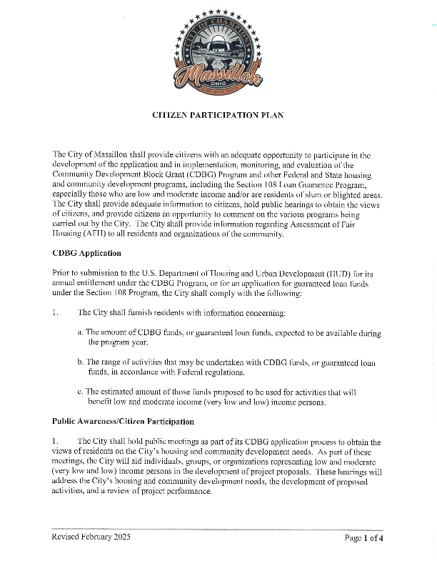
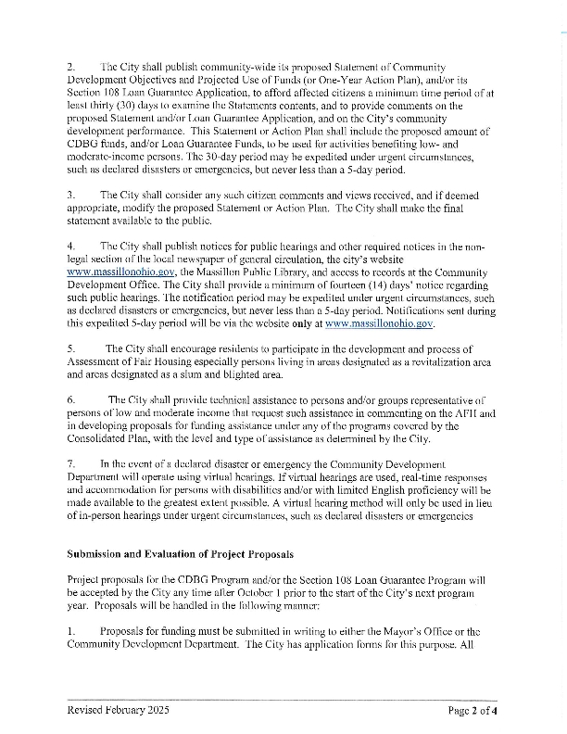
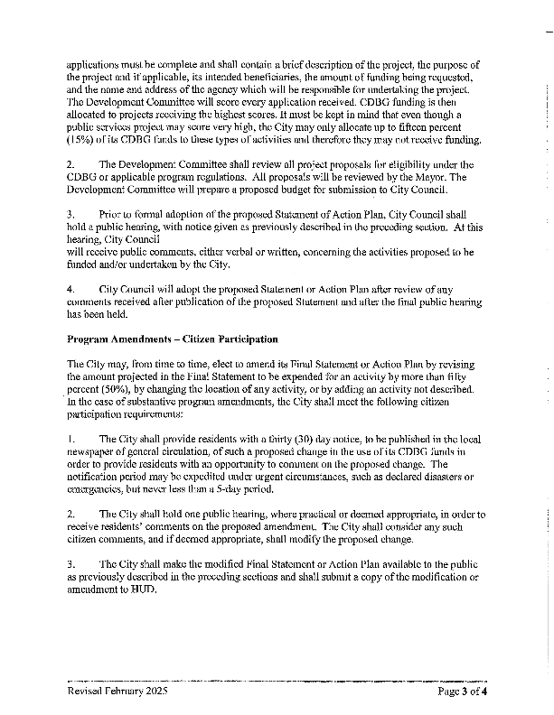
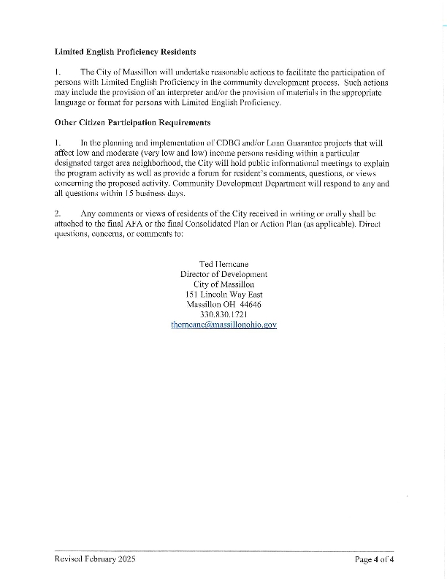

Newspaper Ads
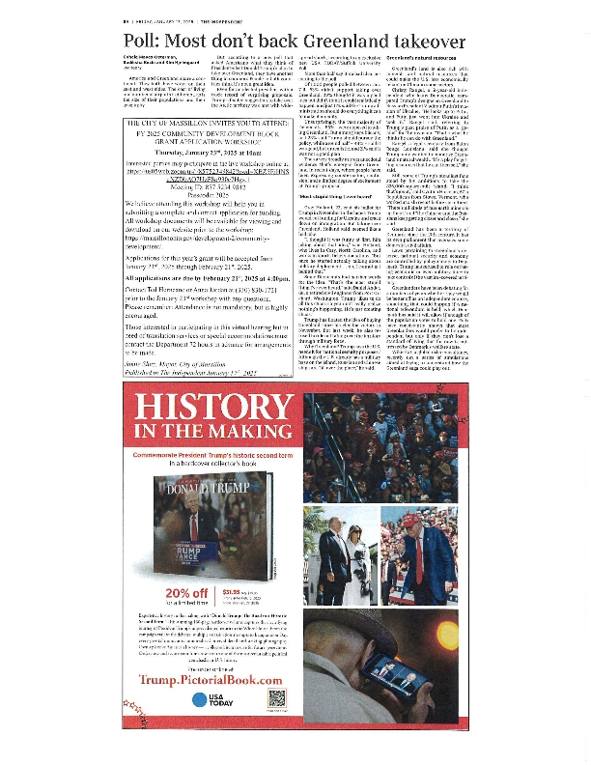
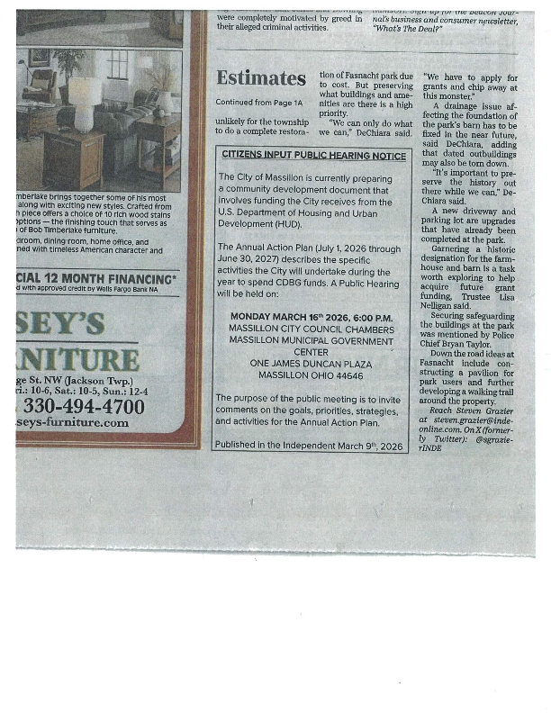
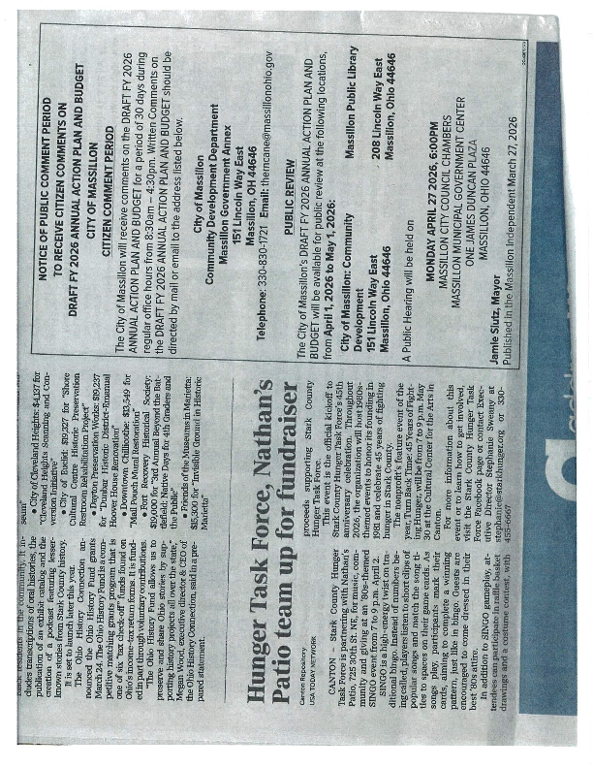

FY 2025 CDBG Application Workshop

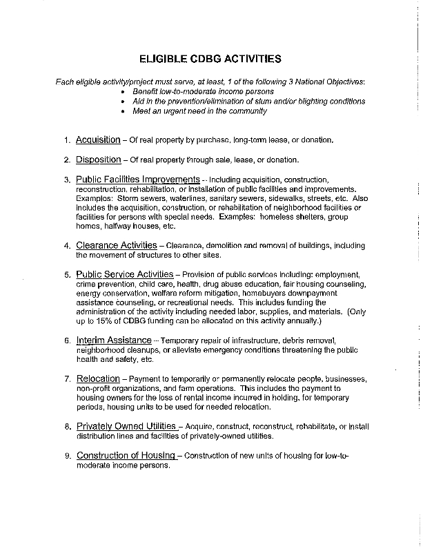
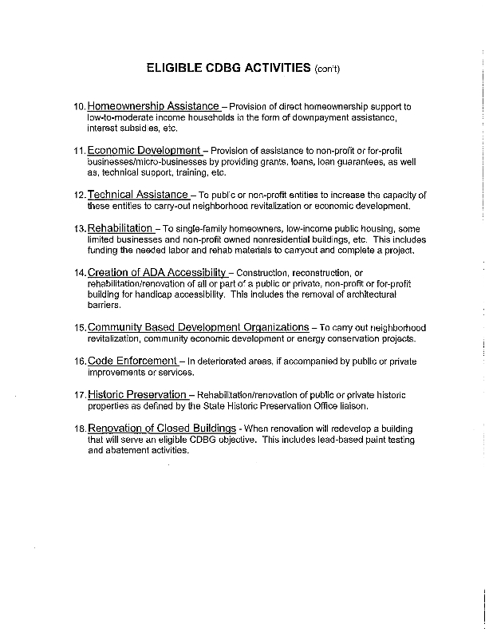
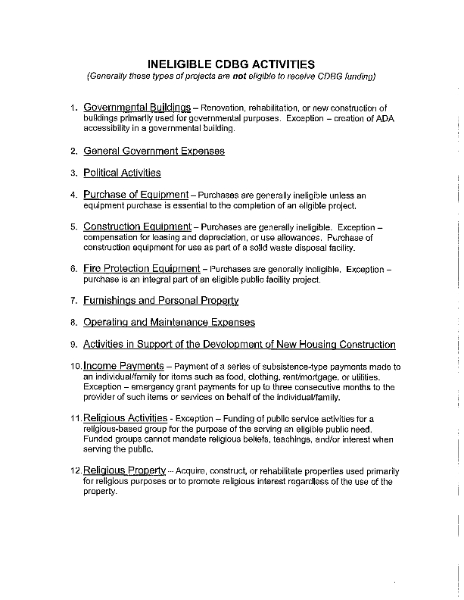
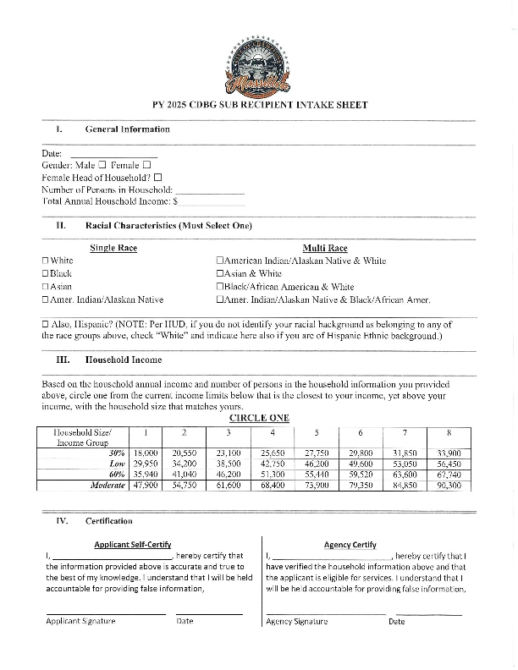
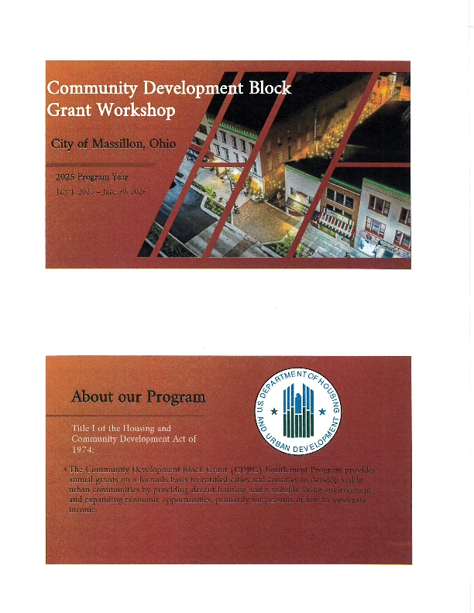
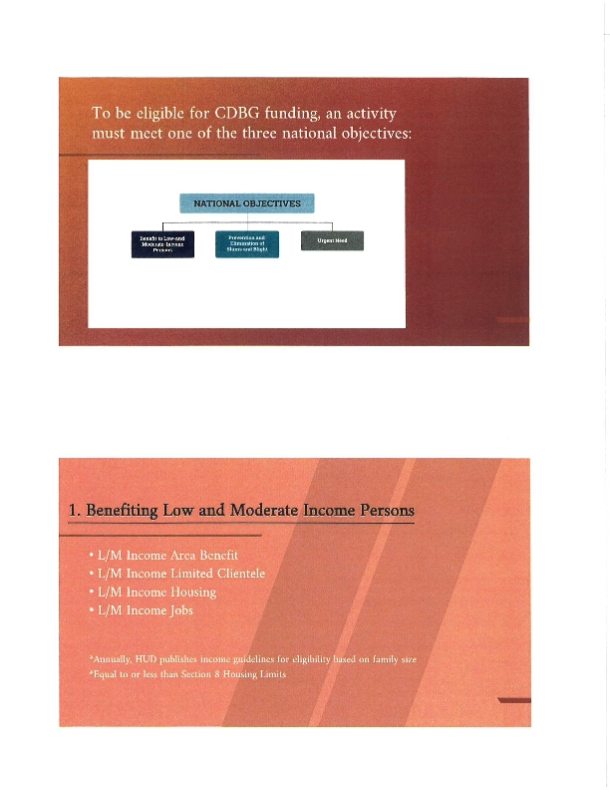
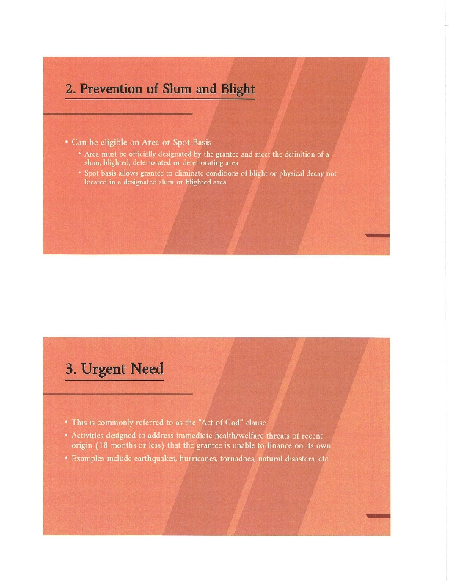
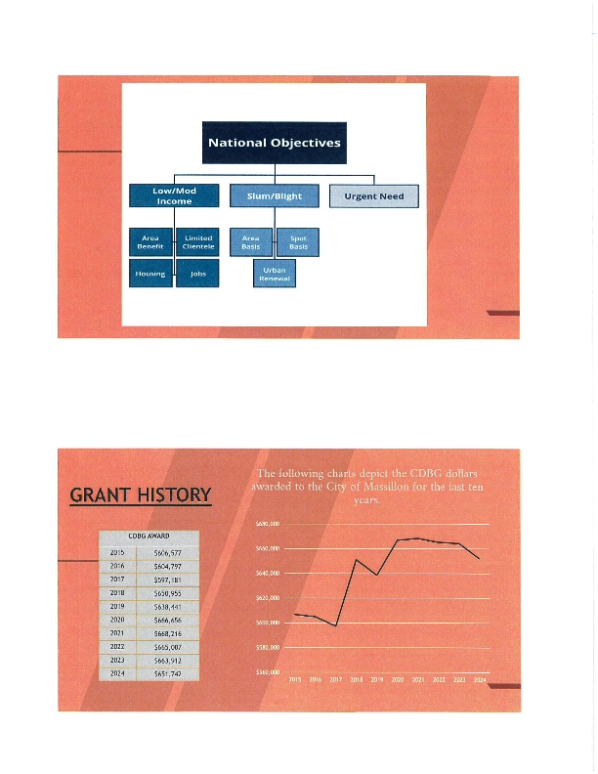
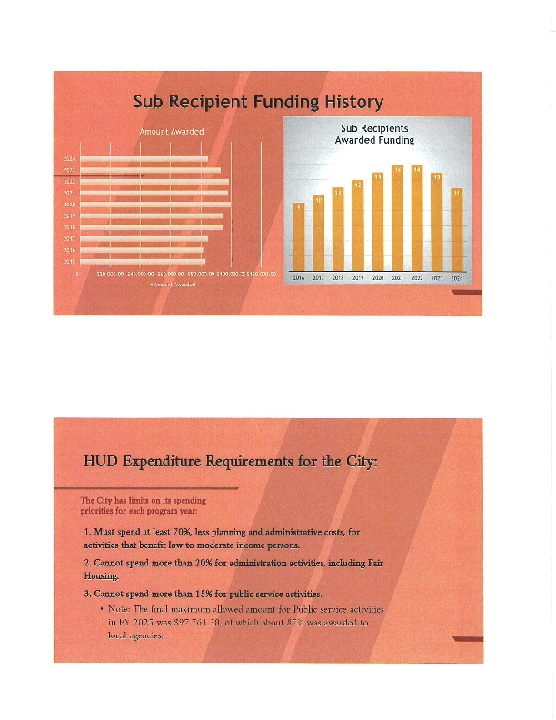
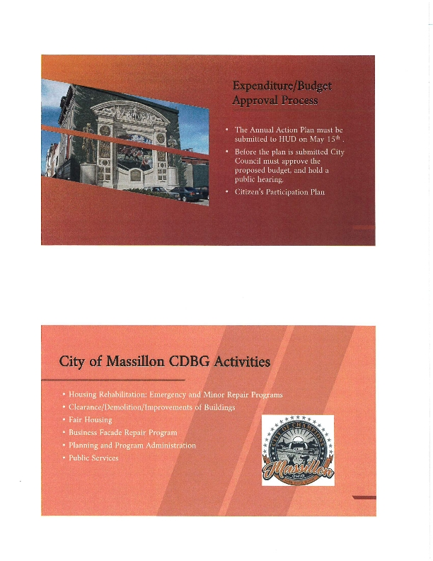
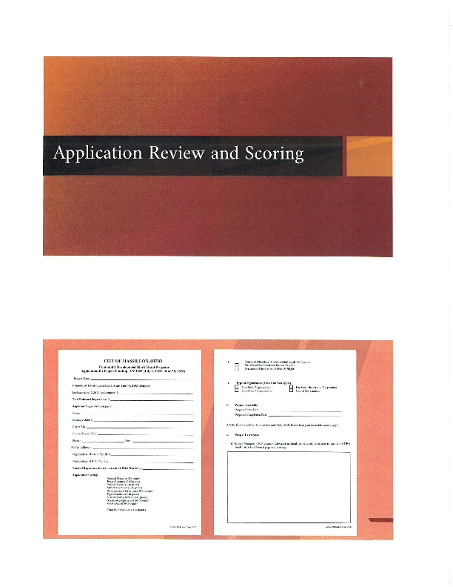
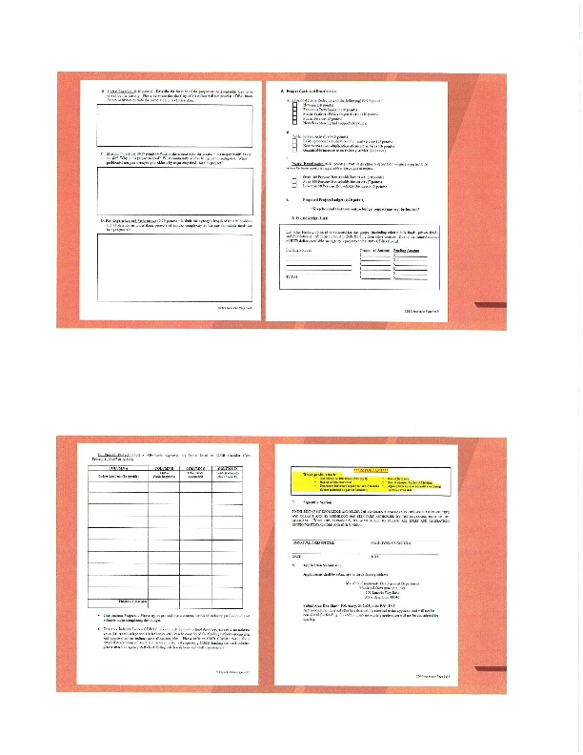
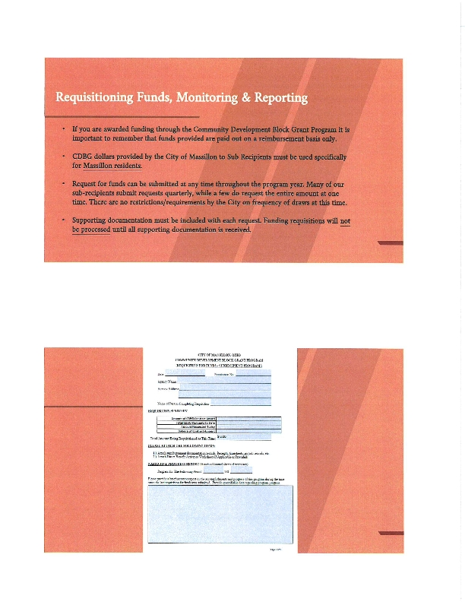
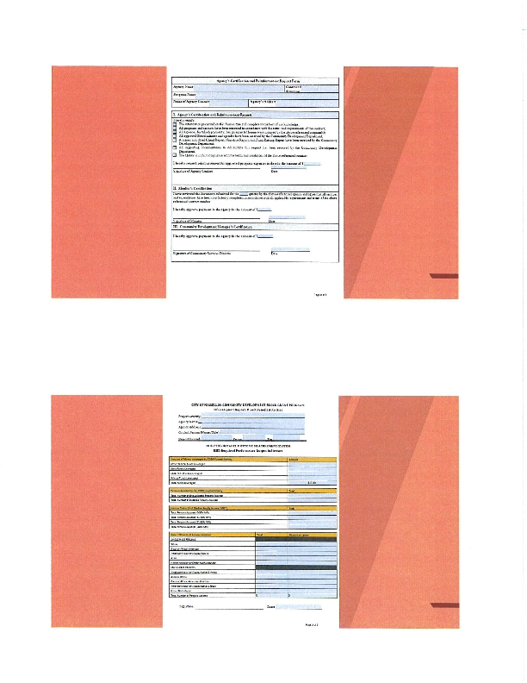
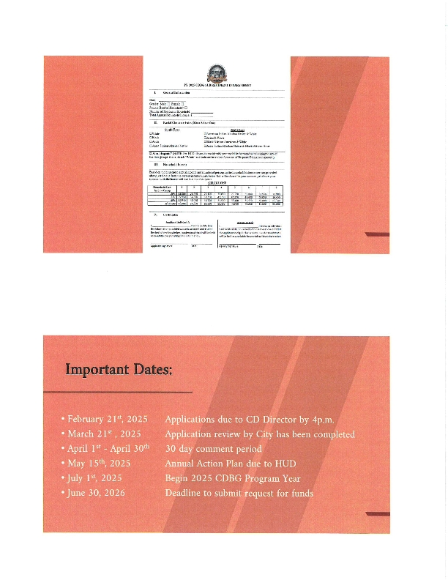
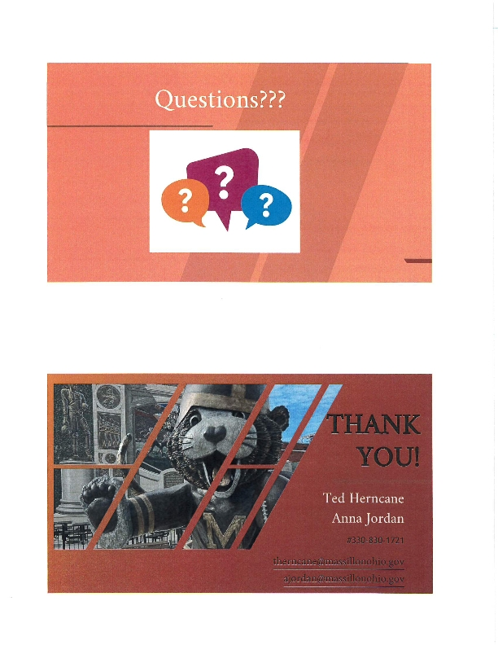
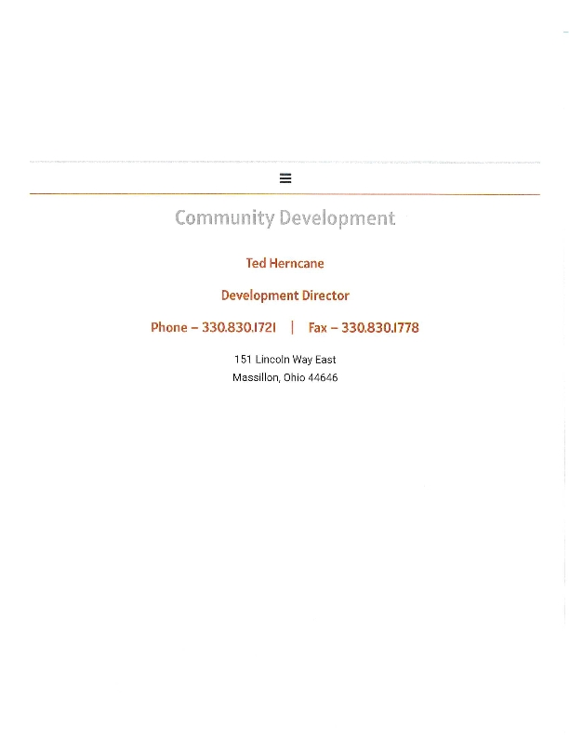
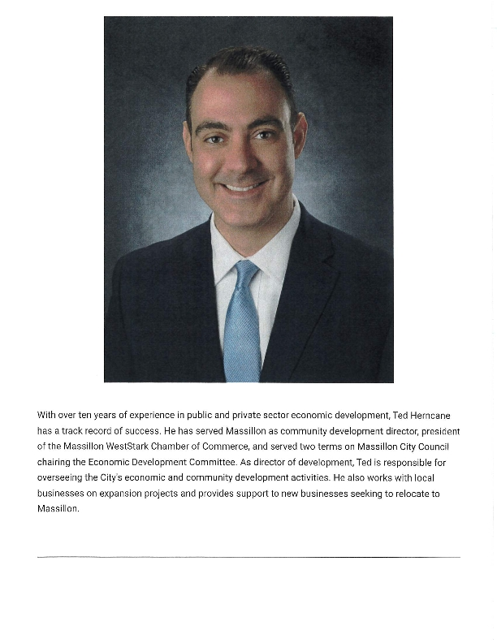
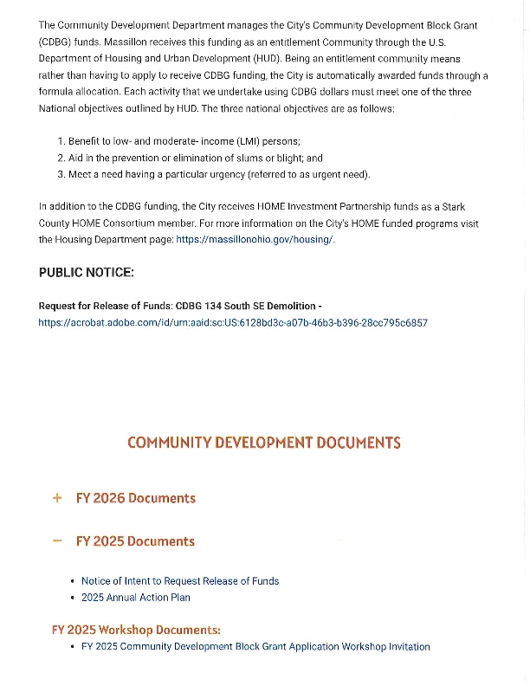
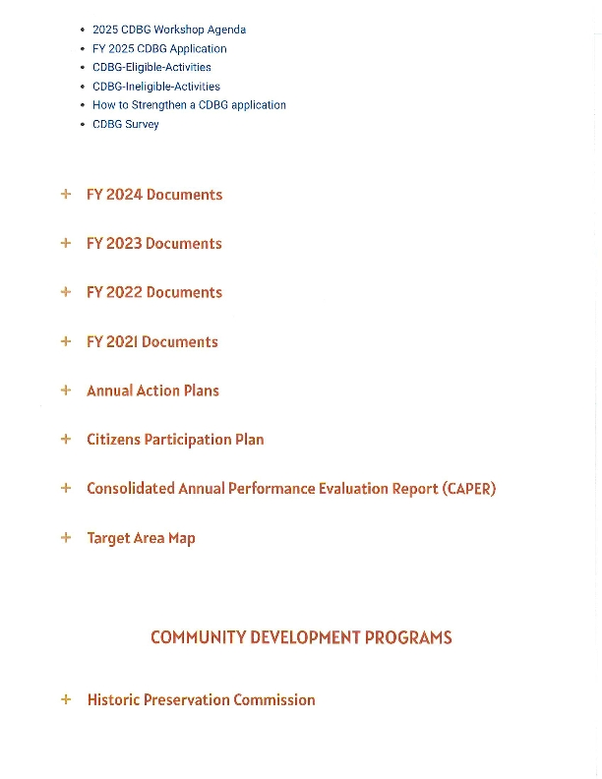
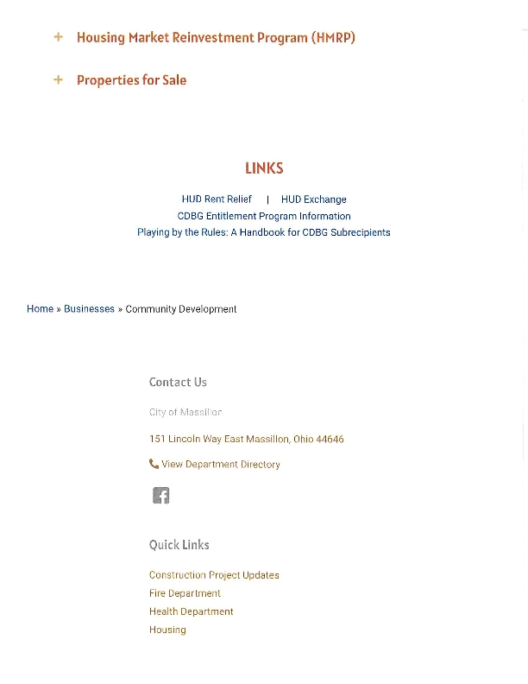
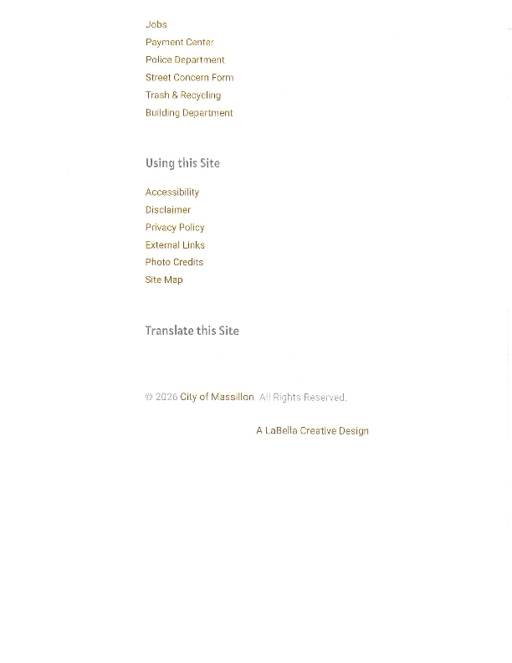

Financial Summary Report
